Arbitrary Power or Current Bus Injection Modeling in PST V2 and PST V3p1

Dan Trudnowski

March 2015

Draft 3

# Introduction

This report describes a new method to model real and reactive power injection into a bus in a PST model. The methodology works both with transient simulation (s_simu.m) and linear analysis (svm_mgen.m). For referencing, I shall call this version of PST version MTech 2.1. This methodology can be used to model many devices such as wind turbines and solar plants, as well as any controls associated with such devices.

Figure 1 is a block diagram of how the power (or current) injection is input into a given bus *i*. The user constructs all device and modelling equations in the function *pwrmod_dyn.m*. The function implements the necessary equations to model the device and control equations that inject the commanded power injection into bus *i*. The model must be constructed in state-space form.

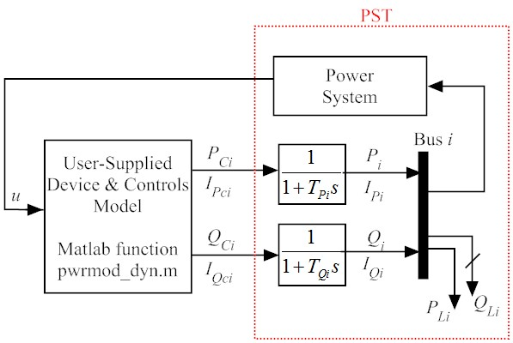

Figure : Block diagram of power modulation approach.

# Declaring modulation Buses

You must include 2 items in the PST data file. First, you must include the matrix *pwrmod_con* which defines the buses and parameters for modulating. Format with an example:

% Power modulation data (sets up modulation of real and reac power injection)

% col 1 bus number

% col 2 real-power time constant (Tp)

% col 3 max real-power modulation (pu on system base)

% col 4 min real-power modulation (pu on system base)

% col 5 reac-power time constant (Tq)

% col 6 max reac-power modulation (pu on system base)

% col 7 min reac-power modulation (pu on system base)

% NOTE: This creates b_pwrmod_p and b_pwrmod_q for the linear analysis.

% b_pwrmod_*(:,j) corresponds to row j of pwrmod_con.

pwrmod_con=[...

%bus T Pmax Pmin Tq Qmax Qmin

2 0.05 1 -1 0.05 1 -1;

3 0.05 1 -1 0.05 1 -1];

This example sets modulation at buses 2 and 3. NOTE: YOU MUST ALSO DECLARE ALL MODULATION BUSES AS EITHER CONSTANT POWER P/Q OR CONSTANT CURRENT P/Q USING *load_con* IN THE DATA FILE.

# Example 1: Simple power pulsing

Consider the system in Figure 2. Power modulation injection is placed into buses 2 and 3 using a constant-power injection model. The data file is *d2m_pwrmod1.m*. For this example, a 0.5 sec. pulse at t = 1 sec. is added at bus 2, and a 0.5 sec. pulse at t = 4 sec. is added at bus 3. The model is in *pwrmod_dyn_Example1.m*. The script to run both the linear and non-linear simulations and plot the results is the file *Example1.m*. The results are shown in Figure 3. The linear and nonlinear responses match exactly as one would expect for such a small input.

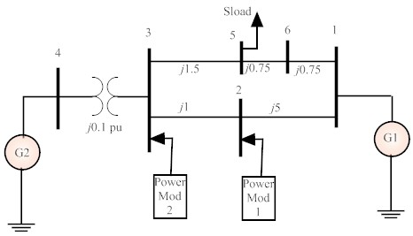

Figure : Example one-line.



Figure 3: Example 1 results. Injected P and Q at each modulation bus.



Figure : Example 1 result. Black = nonlinear, red =linear. Note that red is on top of black.

# Example 2: Current Injection Thru a Model

The goal of this example is to simulate the response of the system to current injection for the system in Figure 2. The current injection will be derived as depicted in Figure 4 which is a model of a solar plant. The *Ip* in Figure 4 is the current injection into modulation buses 2 and 3 in Figure 1. The model is in *pwrmod_dyn_Example2.m*. The script to run both the linear and non-linear simulations and plot the results is the file *Example2.m*. The result is shown in Figure 5. The linear and nonlinear responses match exactly as one would expect for such a small input.

In order to run the linear model, the contents of *powrmod_dyn.m* must be linearized outside of PST and then connected to the PST linear model. This is done at lines 26 thru 41 in *Example2.m*.

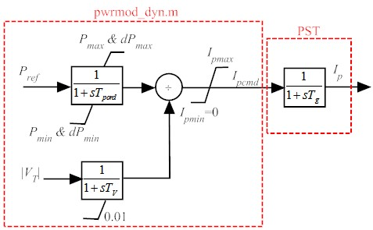

Figure : Example 2 current injection model.



Figure 6: Example 2 results. Injected IP and IQ at each modulation bus



Figure : Example 2 result. Black = nonlinear, red =linear. Note that red is on top of black.